DEVOPS LAB
B.Tech. III Year I Sem.
List of Experiments

- Write code for a simple user registration form for an event.

- Explore Git and GitHub commands.

- Practice Source code management on GitHub. Experiment with the source code in exercise 1.

- Jenkins installation and setup, explore the environment.
- Demonstrate continuous integration and development using Jenkins.

- Explore Docker commands for content management.

- Develop a simple containerized application using Docker.

- Integrate Kubernetes and Docker

- Automate the process of running containerized application for exercise 7 using Kubernetes.
- Install and Explore Selenium for automated testing.

- Write a simple program in JavaScript and perform testing using Selenium.

- Develop test cases for the above containerized application using selenium.

Introduction to DevOps
What is DevOps?
DevOps is a combination of Development (Dev) and Operations (Ops). It is a software development approach that emphasizes collaboration, automation, continuous integration, continuous delivery, and monitoring to deliver high-quality software faster and more reliably.
Definition
DevOps is a culture, set of practices, and collection of tools that improve collaboration between software development and IT operations teams to deliver applications quickly and efficiently.
Why DevOps?
Traditional software development often faced problems such as:
- Poor communication between developers and operations teams.
- Slow software releases.
- Frequent deployment failures.
- Manual processes leading to errors.
- Difficulty in maintaining system stability.
DevOps solves these problems by promoting collaboration and automation.
Key Principles of DevOps
- Collaboration between Development and Operations teams.
- Automation of repetitive tasks.
- Continuous Integration (CI).
- Continuous Delivery/Deployment (CD).
- Infrastructure as Code (IaC).
- Continuous Monitoring.
- Faster and reliable software delivery.

Benefits of DevOps
- Faster software delivery.
- Improved collaboration.
- Higher deployment frequency.
- Reduced deployment failures.
- Faster recovery from failures.
- Improved software quality.
- Better customer satisfaction.
- Reduced operational costs.
- DevOps Tools
- version Control: Git, GitHub, GitLab, Bitbucket
- CI/CD: Jenkins, GitHub Actions, GitLab CI/CD, CircleCI
- Configuration Management: Ansible, Puppet, Chef
- Containerization: Docker, Podman
- Container Orchestration: Kubernetes, OpenShift
- Infrastructure as Code (IaC): Terraform, Pulumi, AWS CloudFormation
- Cloud Platforms: AWS, Microsoft Azure, Google Cloud Platform (GCP)

Introduction to HTML
HTML (HyperText Markup Language) is the standard markup language used to create web pages. It provides the basic structure of a webpage by using elements and tags. HTML tells the web browser how to display text, images, links, tables, forms, and other content.
Features of HTML
- Easy to learn and use.
- Platform-independent (works on any operating system).
- Used to create the structure of web pages.
- Supports multimedia such as images, audio, and video.
- Can be combined with CSS for styling and JavaScript for interactivity.
Basic HTML Document Structure
<!DOCTYPE html>

<head>
<title>My First Web Page</title>
</head>
<body>
<h1>Welcome to HTML</h1>
<p>This is my first HTML page.</p>
</body>
</html>
Explanation
- <!DOCTYPE html> – Declares the document as HTML5.
- <html> – The root element of the webpage.
- <head> – Contains information about the webpage (title, metadata, links to CSS, etc.).
- <title> – Sets the title shown in the browser tab.
- <body> – Contains all the visible content of the webpage.
- <h1> – Defines a main heading.
- <p> – Defines a paragraph.

Experiment1:
Aim: Write code for a simple user registration form for an event.
<!DOCTYPE html>
<html>
<head>
<title>Event Registration Form</title>
</head>
<body>
<h2>Event Registration Form</h2>
<form>
<label for="name">Full Name:</label><br>
<input type="text" id="name" name="name" required><br><br>
<label for="email">Email:</label><br>
<input type="email" id="email" name="email" required><br><br>
<label for="phone">Phone Number:</label><br>
<input type="tel" id="phone" name="phone"><br><br>
<label>Gender:</label><br>
<input type="radio" id="male" name="gender" value="Male">
<label for="male">Male</label>
<input type="radio" id="female" name="gender" value="Female">
<label for="female">Female</label>
<input type="radio" id="other" name="gender" value="Other">
<label for="other">Other</label><br><br>
<label for="event">Select Event:</label><br>
<select id="event" name="event">
<option value="Workshop">Workshop</option>
<option value="Seminar">Seminar</option>
<option value="Hackathon">Hackathon</option>
<option value="Conference">Conference</option>
</select><br><br>
<input type="submit" value="Register">
<input type="reset" value="Reset">
</form>
</body>
</html>
Output:
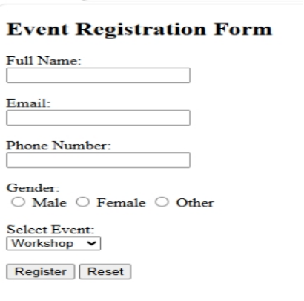

Experiment2:

2. EXPLORE GIT AND GITHUB COMMANDS.

Objective:
The objective of this experiment is to familiarise participants with essential Git concepts and commands, enabling them to effectively use Git for version control and collaboration.
Git is a distributed version control system (VCS) that helps developers track changes in their codebase, collaborate with others, and manage different versions of their projects efficiently. It was created by Linus Torvalds in 2005 to address the shortcomings of existing version control systems.
Unlike traditional centralised VCS, where all changes are stored on a central server, Git follows a distributed model. Each developer has a complete copy of the repository on their local machine, including the entire history of the project. This decentralisation offers numerous advantages, such as offline work, faster operations, and enhanced collaboration.
Git is a widely used version control system that allows developers to collaborate on projects, track changes, and manage codebase history efficiently. This experiment aims to provide a hands-on introduction to Git and explore various fundamental Git commands. Participants will learn how to set up a Git repository, commit changes, manage branches, and collaborate with others using Git.
Advantages of Version Control:
- Versioning is Automatic.
- Team Collaboration is simple.
- Easy Access to previous Versions.
- Only modified code is stored across different versions, hence saves storage.
Types of Version Control Systems

- Local Version Control Systems: A simple database that keeps all changes to files on your local disk.
- Centralized Version Control Systems (CVCS): A single server stores all the versions of a project’s files, and clients check out files from this central place. Examples: SVN (Apache Subversion).
- Distributed Version Control Systems (DVCS): Each contributor has a full copy of the repository, including its history. This allows for greater redundancy and collaboration. Examples: Git.

Working Directory:
The place where your project resides in your local disk. This project may or may not be tracked by git In either case, the directory is called the working directory

The project can be tracked by git, by using the command git init. By doing git init, it automatically creates a hidden .git folder
once we are in the working directory, we have to specify which files are to be tracked by git. We do not specify all files to be tracked in git, because some files could be temporary data which is being generated while execution. To add files in the staging area, we use the command git add.
Commit:
Once the files are selected and are ready in the staging area, they can now be saved in repository. Saving a file in the repository of git is known as doing a commit When we commit a repository in git, the commit is identified by a commit id.
The command for initializing this process is git commit –m “message”
Key Concepts:
- Repository: A Git repository is a collection of files, folders, and their historical versions. It contains all the information about the project's history, branches, and commits.
- Commit: A commit is a snapshot of the changes made to the files in the repository at a specific point in time. It includes a unique identifier (SHA-1 hash), a message describing the changes, and a reference to its parent commit(s).
- Branch: A branch is a separate line of development within a repository. It allows developers to work on new features or bug fixes without affecting the main codebase. Branches can be merged back into the main branch when the changes are ready.
- Merge: Merging is the process of combining changes from one branch into another. It integrates the changes made in a feature branch into the main branch or any other target branch.

- Pull Request: In Git hosting platforms like GitHub, a pull request is a feature that allows developers to propose changes from one branch to another. It provides a platform for code review and collaboration before merging.

- Remote Repository: A remote repository is a copy of the Git repository stored on a server, enabling collaboration among multiple developers. It can be hosted on platforms like GitHub, GitLab, or Bitbucket

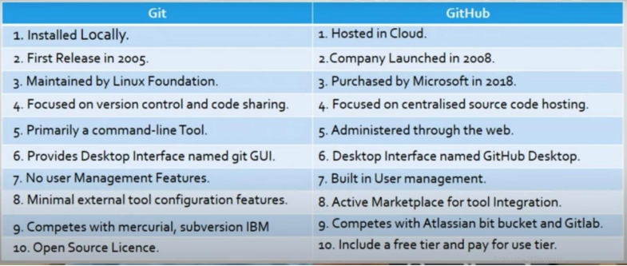

staging Area: Git commands:
Step 1: Check if Git is installed
git –version
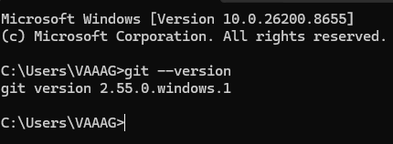
Use: Displays the installed Git version.
Step 2: Configure Git
git config --global user.name "Your Name"
Use: Sets the username for all Git commits.
git config --global user.email youremail@example.com
Use: Sets the email associated with your commits.
git config –list
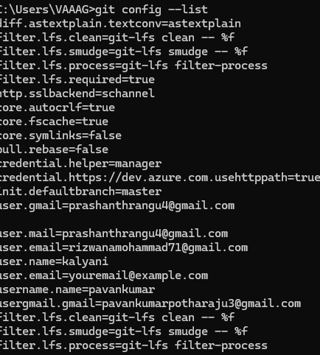
Use: Shows all Git configuration settings.
Step 3: Create a New Repository
mkdir git-repo
Use: Creates a new directory.
cd git-repo
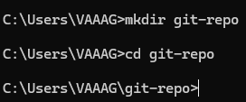
Use: Changes the current working directory.
git init
Use: Creates a new Git repository.
Step 4: Check Repository Status
git status
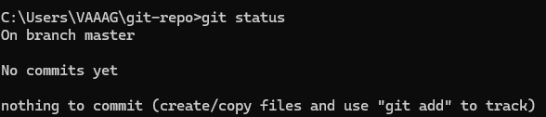
Use: Shows modified, staged, and untracked files.
Step 5: Create a File
Notepad file.txt
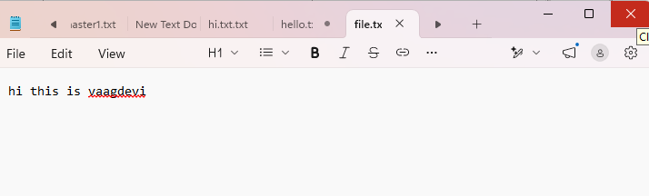
Step 6: Add Files to the Staging Area
Add one file:
git add file.txt
Use: Stages a specific file for commit.
add multiple files
git add .
Use: Stages all changed files.
Step 7: Commit Changes
git commit -m "Initial commit"
Use: Saves staged changes with a commit message.
Step 8: View Commit History
git log
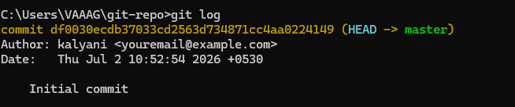
Use: Displays the complete commit history.
Short version:
git log –oneline
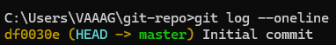
Use: Shows a concise commit history.
Git Branch and Merge
Introduction to Git Branch
A Git branch is a separate line of development in a Git repository. Branches allow developers to work on new features, bug fixes, or experiments without affecting the main project. Once the work is completed and tested, the branch can be merged back into the main branch.
For example, a developer can create a branch named feature-login to develop a login feature while other developers continue working on the main branch.

Step 9: Create a Branch
git branch feature
Use: Creates a new branch named feature.
git branch
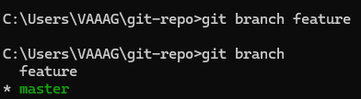
Use: Displays all local branches.
Step 10: Switch Branch
git checkout feature
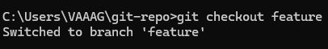
Use: Switches to the feature branch.
Step 11: Merge Branches
Introduction to Git Merge
Git Merge is the process of combining changes from one branch into another. It is commonly used to merge a feature branch into the main branch after development and testing are complete.
For example:
- A developer creates a branch called feature-login.
- After completing the login feature, the developer merges it into the main branch using the git merge command.
Switch to the main branch:
git checkout master
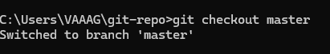
Merge another branch:
git merge feature
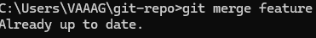
Use: Combines the changes from feature into main.
Step 12: Delete a Branch
git branch -d feature
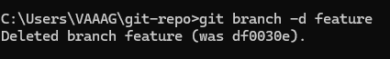
Use: Deletes a branch after it has been merged.
git branch -D feature
Use: Deletes a branch even if it has not been merged.

GitHub Commands:
Step 13: Create a Repository on GitHub
Create a new repository on GitHub using your web browser.
Step 14: Connect Local Repository to GitHub
git remote add origin https:Ugithub.com/username/repository.gjt Use: Links your local repository to the remote GitHub repository.
Check the remote:
git remote -v
Use: Displays configured remote repositories.
Step 15: Push Code to GitHub git push -u origin main
Use: Uploads your local main branch to GitHub and sets the upstream branch. git push
Use: Uploads the latest commits to GitHub.
Step 16: Clone an Existing Repository
git clone https://github.com/username/repository.git
Use: Downloads an existing GitHub repository to your computer.
Step 17: Pull Latest Changes
git pull origin main
Use: Downloads and merges the latest changes from GitHub.

Step 18: Fetch Changes
git fetch
Use: Downloads updates from the remote repository without merging them. git rm file.bet
Use: Removes a tracked file. Stop tracking but keep the file:
git rm -cached file.bet
Use: Removes the file from Git while leaving it on your computer.

Experiment 3:

3. Practice Source code management on GitHub. Experiment with the source code in exercise 1.
Step 1: Download and install required git version.
Step 2: check the know git version using command :
$git --version
Step 3: set up your information in bash type below commands
$ git config --global user name "Your Name"
$ git config --global user. email Your email@example.com"
To push a repository
Open text editor
Create a file named Registration.html
Registration.html
Event Registration Form
Here's a simple example of a registration HTML file:
Aim:Write code for a simple user registration form for an event.
<!DOCTYPE html>
<html>
<head>
<title>Event Registration Form</title>
</head>
<body>
<h2>Event Registration Form</h2>
<form>
<label for="name">Full Name:</label><br>
<input type="text" id="name" name="name" required><br><br>
<label for="email">Email:</label><br>
<input type="email" id="email" name="email" required><br><br>
<label for="phone">Phone Number:</label><br>
<input type="tel" id="phone" name="phone"><br><br>
<label>Gender:</label><br>
<input type="radio" id="male" name="gender" value="Male">
<label for="male">Male</label>
<input type="radio" id="female" name="gender" value="Female">
<label for="female">Female</label>
<input type="radio" id="other" name="gender" value="Other">
<label for="other">Other</label><br><br>
<label for="event">Select Event:</label><br>
<select id="event" name="event">
<option value="Workshop">Workshop</option>
<option value="Seminar">Seminar</option>
<option value="Hackathon">Hackathon</option>
<option value="Conference">Conference</option>
</select><br><br>
<input type="submit" value="Register">
<input type="reset" value="Reset">
</form>
</body>
</html>
Step 4: Save the file
Go to file location Right click on the file Click on open with Select git bash
Now use the following commands to push file into git repository Initialize git
$ git init
Step 5: Add files to your Repo
$ git add Registration.html
Step 6: commit your changes bash:
$ git commit -m
a Remote Repository in github Link it to local Repo
bash:
$ git remote add origin https://github.com/youruserName/yourRepository.git
$ git branch -m master main
$ git push-u origin master main
$ git status
$ git remote -v

Experiment 4:
4 Jenkins installation and setup,explore the environment.
Installing Jenkins
Jenkins is a widely used open-source automation server that helps automate software development tasks, especially continuous integration (CI) and continuous delivery/deployment (CD).
Some of its main capabilities include:
- Continuous Integration (CI): Automatically builds and tests code whenever developers commit changes.
- Continuous Delivery/Deployment (CD): Automates deployment to testing, staging, or production environments.
- Pipeline as Code: Define build and deployment workflows using a Jenkinsfile.
- Plugin Ecosystem: Thousands of plugins integrate Jenkins with tools like Git, Docker, Kubernetes, Maven, Gradle, SonarQube, Slack, and cloud platforms.
- Distributed Builds: Run jobs across multiple agent machines to improve scalability.

Advantages
- Free and open source.
- Large community and extensive plugin support.
- Supports many programming languages and build tools.
- Highly customizable.
- Integrates with most DevOps tools.
- Limitations -+
- Can require significant maintenance as installations grow.
- Plugin compatibility issues can occur after upgrades.
- UI is functional but less modern than some newer CI/CD platforms.

jenkins installations
prerequisite
java,JRE,JDK
JDK 17 OR JDK 21 is required.
Install java from oracle website
Step 1: Setup wizard
On opening the Windows Installer, an Installation Setup Wizard appears, Click Next on the Setup Wizard to start your installation.
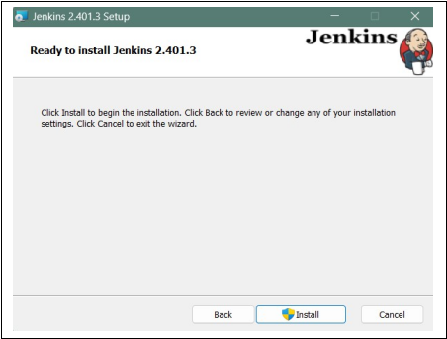

Step 2: Select destination folder
Select the destination folder to store your Jenkins Installation and click Next to continue.
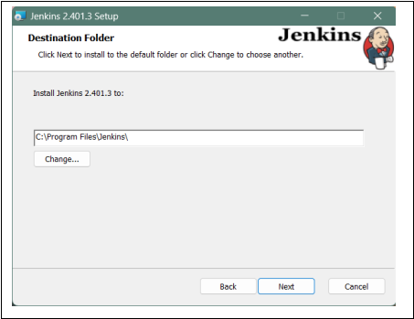

Step 3: Service logon credentials
When Installing Jenkins, it is recommended to install and run Jenkins as an independent windows service using a local or domain user as it is much safer than running Jenkins using Local System(Windows equivalent of root) which will grant Jenkins full access to your machine and services.

To run Jenkins service using a local or domain user, specify the domain user name and password with which you want to run Jenkins, click on Test Credentials to test your domain credentials and click on Next.
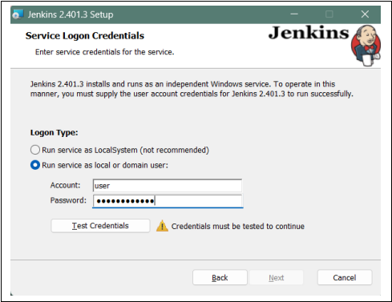

Step 4: Port selection
Specify the port on which Jenkins will be running, Test Port button to validate whether the specified port if free on your machine or not. Consequently, if the port is free, it will show a green tick mark as shown below, then click on Next.
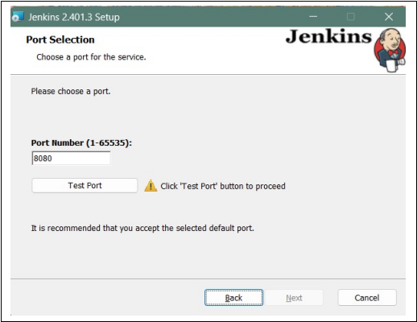

Step 5: Select Java home directory
The installation process checks for Java on your machine and prefills the dialog with the Java home directory. If the needed Java version is not installed on your machine, you will be prompted to install it.

Once your Java home directory has been selected, click on Next to continue.
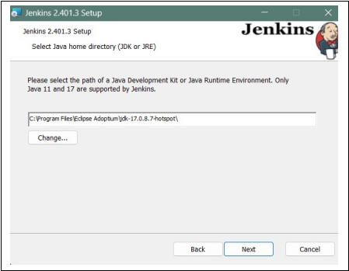

Step 6: Custom setup
Select other services that need to be installed with Jenkins and click on Next.
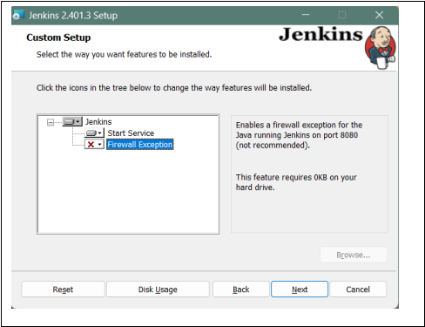
Step 7: Install Jenkins
Click on the Install button to start the installation of Jenkins.
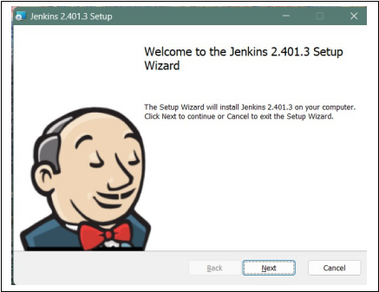

Additionally, clicking on the Install button will show the progress bar of installation, as shown below:
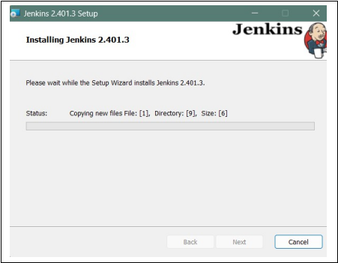

Step 8: Finish Jenkins installation
Once the installation completes, click on Finish to complete the installation.
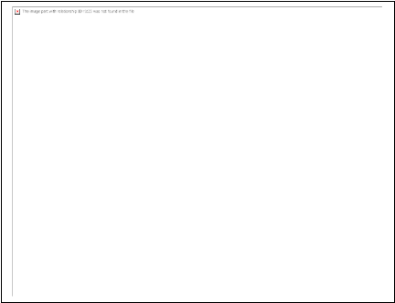

Jenkins will be installed as a Windows Service. You can validate this by browsing the services section, as shown below:
